Module 2
Git Assignment-3
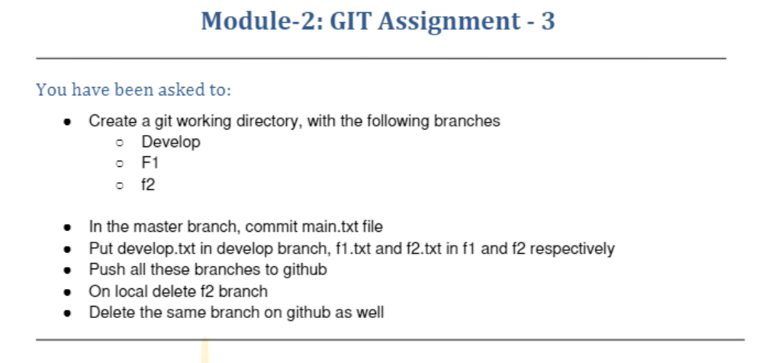
ubuntu@ip-172-31-25-3:~$ mkdir assmt3
ubuntu@ip-172-31-25-3:~$ cd assmt3
ubuntu@ip-172-31-25-3:~/assmt3$ git init
Initialized empty Git repository in /home/ubuntu/assmt3/.git/
ubuntu@ip-172-31-25-3:~/assmt3$ git branch
ubuntu@ip-172-31-25-3:~/assmt3$ git add .
ubuntu@ip-172-31-25-3:~/assmt3$ git commit -m "first commit"
On branch master

Initial commit

nothing to commit (create/copy files and use "git add" to track)
ubuntu@ip-172-31-25-3:~/assmt3$ git status
On branch master

No commits yet

nothing to commit (create/copy files and use "git add" to track)
ubuntu@ip-172-31-25-3:~/assmt3$ git branch Develop
fatal: Not a valid object name: 'master'.
ubuntu@ip-172-31-25-3:~/assmt3$ vi main.txt
ubuntu@ip-172-31-25-3:~/assmt3$ ls
main.txt
ubuntu@ip-172-31-25-3:~/assmt3$ git status
On branch master

No commits yet

Untracked files:
(use "git add <file>..." to include in what will be committed)
main.txt

nothing added to commit but untracked files present (use "git add" to track)
ubuntu@ip-172-31-25-3:~/assmt3$ git add .
ubuntu@ip-172-31-25-3:~/assmt3$ git commit -m "this is main.txt"
[master (root-commit) 4183226] this is main.txt
1 file changed, 1 insertion(+)
create mode 100644 main.txt
ubuntu@ip-172-31-25-3:~/assmt3$ git status
On branch master
nothing to commit, working tree clean
ubuntu@ip-172-31-25-3:~/assmt3$ git branch Develop
ubuntu@ip-172-31-25-3:~/assmt3$ git branch f1
ubuntu@ip-172-31-25-3:~/assmt3$ git branch f2
ubuntu@ip-172-31-25-3:~/assmt3$ git status
On branch master
nothing to commit, working tree clean
ubuntu@ip-172-31-25-3:~/assmt3$ git branch
Develop
f1
f2
* master
ubuntu@ip-172-31-25-3:~/assmt3$ git checkout Develop
Switched to branch 'Develop'
ubuntu@ip-172-31-25-3:~/assmt3$ vi develop.txt
ubuntu@ip-172-31-25-3:~/assmt3$ ls
develop.txt main.txt
ubuntu@ip-172-31-25-3:~/assmt3$ git checkout f1
Switched to branch 'f1'
ubuntu@ip-172-31-25-3:~/assmt3$ vi f1.txt
ubuntu@ip-172-31-25-3:~/assmt3$ git branch
Develop
* f1
f2
master
ubuntu@ip-172-31-25-3:~/assmt3$ ls
develop.txt f1.txt main.txt
ubuntu@ip-172-31-25-3:~/assmt3$ git branch f2
fatal: A branch named 'f2' already exists.
ubuntu@ip-172-31-25-3:~/assmt3$ git checkout f2
Switched to branch 'f2'
ubuntu@ip-172-31-25-3:~/assmt3$ vi f2.txt
ubuntu@ip-172-31-25-3:~/assmt3$ ls
develop.txt f1.txt f2.txt main.txt
ubuntu@ip-172-31-25-3:~/assmt3$ git branch
Develop
f1
* f2
master
ubuntu@ip-172-31-25-3:~/assmt3$ git remote add origin "git@github.com:vcgatate/Git_Assignment_3.git"
ubuntu@ip-172-31-25-3:~/assmt3$ git push origin master
Enumerating objects: 3, done.
Counting objects: 100% (3/3), done.
Writing objects: 100% (3/3), 229 bytes | 229.00 KiB/s, done.
Total 3 (delta 0), reused 0 (delta 0)
remote:
remote: Create a pull request for 'master' on GitHub by visiting:
remote: https://github.com/vcgatate/Git_Assignment_3/pull/new/master
remote:
To github.com:vcgatate/Git_Assignment_3.git
* [new branch] master -> master
ubuntu@ip-172-31-25-3:~/assmt3$ git push origin Develop
Total 0 (delta 0), reused 0 (delta 0)
remote:
remote: Create a pull request for 'Develop' on GitHub by visiting:
remote: https://github.com/vcgatate/Git_Assignment_3/pull/new/Develop
remote:
To github.com:vcgatate/Git_Assignment_3.git
* [new branch] Develop -> Develop
ubuntu@ip-172-31-25-3:~/assmt3$ git push origin f1
Total 0 (delta 0), reused 0 (delta 0)
remote:
remote: Create a pull request for 'f1' on GitHub by visiting:
remote: https://github.com/vcgatate/Git_Assignment_3/pull/new/f1
remote:
To github.com:vcgatate/Git_Assignment_3.git
* [new branch] f1 -> f1
ubuntu@ip-172-31-25-3:~/assmt3$ git push origin f2
Total 0 (delta 0), reused 0 (delta 0)
remote:
remote: Create a pull request for 'f2' on GitHub by visiting:
remote: https://github.com/vcgatate/Git_Assignment_3/pull/new/f2
remote:
To github.com:vcgatate/Git_Assignment_3.git
* [new branch] f2 -> f2
ubuntu@ip-172-31-25-3:~/assmt3$ git branch
Develop
f1
f2
* master
ubuntu@ip-172-31-25-3:~/assmt3$ git checkout Develop
Switched to branch 'Develop'
ubuntu@ip-172-31-25-3:~/assmt3$ ls
develop.txt f1.txt f2.txt main.txt
ubuntu@ip-172-31-25-3:~/assmt3$ git branch -D f2
Deleted branch f2 (was 4183226).
ubuntu@ip-172-31-25-3:~/assmt3$ git push origin --delete f2
Warning: Permanently added the RSA host key for IP address '140.82.112.3' to the list of known hosts.
To github.com:vcgatate/Git_Assignment_3.git
- [deleted] f2
ubuntu@ip-172-31-25-3:~/assmt3$ git status
On branch Develop
Untracked files:
(use "git add <file>..." to include in what will be committed)
develop.txt
f1.txt
f2.txt

nothing added to commit but untracked files present (use "git add" to track)
ubuntu@ip-172-31-25-3:~/assmt3$ git branch
* Develop
f1
master

After deleting branch f2 in remote repository
